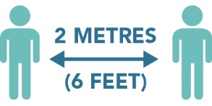**Please Maintain Physical Distancing**

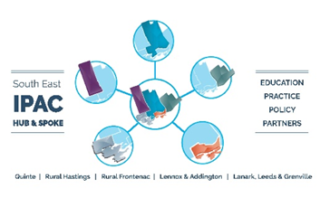**Maximum room occupancy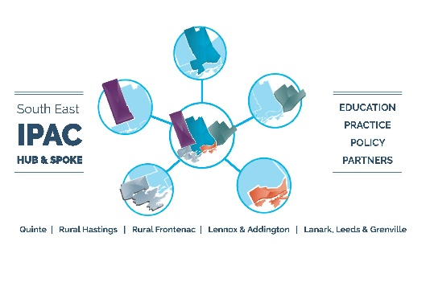:**

**Please keep a mask on at all times unless you are eating or drinking.**

**Put your mask on immediately after nourishment.**

**This space has been optimized for good physical distancing. Please observe the posted rules and do not move furniture.**

**Too many people in here? Try taking your break somewhere else or staggering your breaks.**

**3**