Printing e-visit/Telephone Patient list
To print a list of patients booked for a telephone/e-visit for a physician for a specific date, please follow the below steps:
- Under Decentralized Registration tab and then under the reports heading, please select Telemedicine List for Physicians.
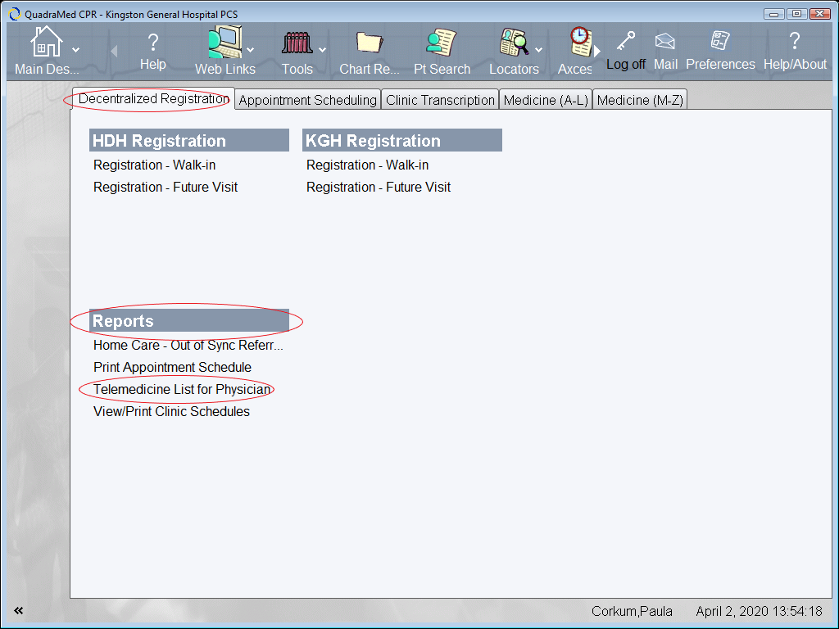
- Please enter the physician, start date and end date fields and press A (Accept) tab at the bottom of the screen to run the report.
